1.Write a Python Program to Solve a 8-Puzzle Problem ?

AIM:
To write a Python program to solve the 8-Puzzle problem using the A* Search Algorithm and find the shortest path from the initial state to the goal state.

ALGORITHM:
- Define the initial state and the goal state of the 8-puzzle.
- Use the A* search algorithm to solve the puzzle.
- Calculate the heuristic value (number of misplaced tiles) for each state.
- Find the position of the blank tile (0).
- Generate all possible next states by moving the blank tile (up, down, left, or right).
- Add the generated states to a priority queue based on their total cost:
  - f(n) = g(n) + h(n)
  - g(n) = cost from the start state.
  - h(n) = heuristic value (misplaced tiles).
- Repeat the process until the goal state is reached.
- Display the sequence of moves from the initial state to the goal state.
- Stop the program when the goal state is found or report that no solution exists.

CODE:
import heapq
# Goal State
goal = [
[1, 2, 3],
[4, 5, 6],
[7, 8, 0]
]
# Find position of blank (0)
def find_blank(state):
for i in range(3):
for j in range(3):
if state[i][j] == 0:
return i, j
# Heuristic: Number of misplaced tiles
def heuristic(state):
count = 0
for i in range(3):
for j in range(3):
if state[i][j] != 0 and state[i][j] != goal[i][j]:
count += 1
return count
# Convert list to tuple for hashing
def to_tuple(state):
return tuple(tuple(row) for row in state)
# Generate possible moves
def get_neighbors(state):
neighbors = []
x, y = find_blank(state)
moves = [(-1,0), (1,0), (0,-1), (0,1)]
for dx, dy in moves:
nx, ny = x + dx, y + dy
if 0 <= nx < 3 and 0 <= ny < 3:
new_state = [row[:] for row in state]
new_state[x][y], new_state[nx][ny] = new_state[nx][ny], new_state[x][y]
neighbors.append(new_state)
return neighbors
# A* Search
def a_star(start):
pq = []
heapq.heappush(pq, (heuristic(start), 0, start, []))
visited = set()
while pq:
f, g, state, path = heapq.heappop(pq)
if state == goal:
return path + [state]
state_tuple = to_tuple(state)
if state_tuple in visited:
continue
visited.add(state_tuple)
for neighbor in get_neighbors(state):
if to_tuple(neighbor) not in visited:
heapq.heappush(
pq,
(g + 1 + heuristic(neighbor),
g + 1,
neighbor,
path + [state])
)
return None
# Driver Code
start = [
[1, 2, 3],
[4, 0, 6],
[7, 5, 8]
]
solution = a_star(start)
if solution:
print("Solution found!\n")
for step in solution:
for row in step:
print(row)
print()
else:
print("No solution exists.")

OUTPUT:
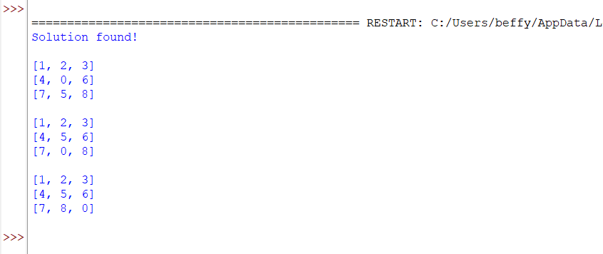

RESULT:
The 8-Puzzle problem was successfully solved using the A* Search Algorithm, and the sequence of moves from the initial state to the goal state was displayed.

2.Write a Python Program to Solve 8-Queen Problem ?

AIM:
To write a Python program to solve the 8-Queen Problem using the Backtracking Algorithm, such that no two queens attack each other.

ALGORITHM:
- Start with an empty 8 × 8 chessboard.
- Place a queen in the first column.
- Check whether the queen is safe by ensuring:
- No other queen is in the same row.
- No other queen is in the upper-left diagonal.
- No other queen is in the lower-left diagonal.
- If the position is safe, place the queen.
- Move to the next column and repeat the process.
- If no safe position is found in a column, backtrack by removing the previously placed queen.
- Continue until all 8 queens are placed successfully.
- Display the final arrangement of the queens on the chessboard.

CODE:
N = 8
# Check if a queen can be placed safely
def is_safe(board, row, col):
# Check left side of current row
for i in range(col):
if board[row][i] == 1:
return False
# Check upper-left diagonal
i, j = row, col
while i >= 0 and j >= 0:
if board[i][j] == 1:
return False
i -= 1
j -= 1
# Check lower-left diagonal
i, j = row, col
while i < N and j >= 0:
if board[i][j] == 1:
return False
i += 1
j -= 1
return True
# Solve using backtracking
def solve(board, col):
if col >= N:
return True
for row in range(N):
if is_safe(board, row, col):
board[row][col] = 1
if solve(board, col + 1):
return True
board[row][col] = 0
return False
# Print solution
def print_solution(board):
print("Solution:")
for row in board:
print(row)
board = [[0] * N for _ in range(N)]
if solve(board, 0):
print_solution(board)
else:
print("No solution exists")

OUTPUT:
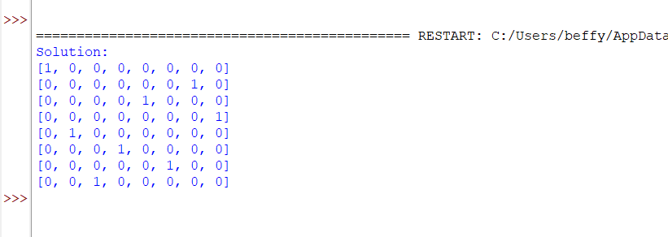

RESULT:
The 8-Queen Problem was successfully solved using the Backtracking Algorithm, and a valid arrangement of 8 queens on the chessboard was obtained such that no two queens attack each other.

3.Write a Python Program for Water Jug Problem ?

AIM:
To write a Python program to solve the Water Jug Problem and obtain the target quantity of water using two jugs.
ALGORITHM:
- Initialize Jug 1 and Jug 2 as empty.
- Fill Jug 1 completely.
- Transfer water from Jug 1 to Jug 2 until Jug 2 is full.
- Empty Jug 2.
- Transfer the remaining water from Jug 1 to Jug 2.
- Fill Jug 1 again.
- Transfer water from Jug 1 to Jug 2 until Jug 2 becomes full.
- Stop when the target quantity (2 litres) is obtained in Jug 1.
- Display "Target Achieved".
CODE:
# Water Jug Problem
# Jug 1 Capacity = 4 Litres
# Jug 2 Capacity = 3 Litres
# Target = 2 Litres
jug1 = 0
jug2 = 0
# Fill Jug1
jug1 = 4
print("Fill Jug1 :", jug1, jug2)
# Transfer Jug1 -> Jug2
transfer = min(jug1, 3 - jug2)
jug1 -= transfer
jug2 += transfer
print("Transfer :", jug1, jug2)
# Empty Jug2
jug2 = 0
print("Empty Jug2 :", jug1, jug2)
# Transfer Jug1 -> Jug2
transfer = min(jug1, 3 - jug2)
jug1 -= transfer
jug2 += transfer
print("Transfer :", jug1, jug2)
# Fill Jug1
jug1 = 4
print("Fill Jug1 :", jug1, jug2)
# Transfer Jug1 -> Jug2
transfer = min(jug1, 3 - jug2)
jug1 -= transfer
jug2 += transfer
print("Transfer :", jug1, jug2)
print("\nTarget Achieved!")

OUTPUT:
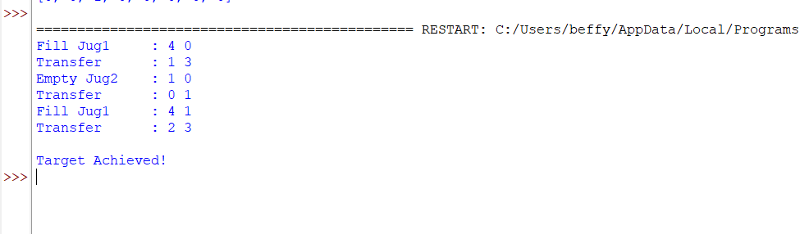

RESULT:
Thus, the Python program to solve the Water Jug Problem was successfully executed, and the target quantity of 2 litres was obtained.
4. Write a Python Program for Cript-Arithmetic Problem?

AIM:
To write a Python program to solve a Crypt-Arithmetic Problem by assigning unique digits to letters such that the arithmetic equation is satisfied.

ALGORITHM:
- Read the words involved in the crypt-arithmetic equation.
- Identify all unique letters.
- Generate all possible digit assignments for the letters.
- Ensure that no leading letter is assigned the digit 0.
- Replace each letter with its assigned digit.
- Check whether the arithmetic equation is satisfied.
- If a valid assignment is found, display the solution.
- Stop the program after finding the correct solution.

CODE:
from itertools import permutations
letters = ('S', 'E', 'N', 'D', 'M', 'O', 'R', 'Y')
for p in permutations(range(10), len(letters)):
d = dict(zip(letters, p))
if d['S'] == 0 or d['M'] == 0:
continue
send = 1000*d['S'] + 100*d['E'] + 10*d['N'] + d['D']
more = 1000*d['M'] + 100*d['O'] + 10*d['R'] + d['E']
money = 10000*d['M'] + 1000*d['O'] + 100*d['N'] + 10*d['E'] + d['Y']
if send + more == money:
print("SEND =", send)
print("MORE =", more)
print("MONEY =", money)
break

OUTPUT:
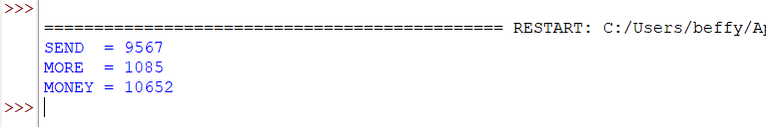

RESULT:
Thus, the Python program to solve the Crypt-Arithmetic Problem was successfully implemented and executed

5. Write a Python Program for Missionaries Cannibel Problem?

AIM:
To write a Python program to solve the Missionaries and Cannibals Problem using the Breadth-First Search (BFS) algorithm.

ALGORITHM:
- Represent the state as (Missionaries Left, Cannibals Left, Boat Side).
- Start with all missionaries and cannibals on the left bank.
- Generate all valid boat moves.
- Ensure that on either bank, missionaries are never outnumbered by cannibals (unless there are no missionaries).
- Use BFS to explore all possible valid states.
- Stop when all missionaries and cannibals reach the right bank.
- Display the sequence of states.

CODE:
from collections import deque
def is_valid(m_left, c_left):
m_right = 3 - m_left
c_right = 3 - c_left
if m_left < 0 or c_left < 0 or m_left > 3 or c_left > 3:
return False
if m_left > 0 and m_left < c_left:
return False
if m_right > 0 and m_right < c_right:
return False
return True
def bfs():
start = (3, 3, 'L')
goal = (0, 0, 'R')
queue = deque([(start, [start])])
visited = set()
moves = [(2,0), (0,2), (1,1), (1,0), (0,1)]
while queue:
state, path = queue.popleft()
if state == goal:
print("Solution Path:")
for step in path:
print(step)
return
if state in visited:
continue
visited.add(state)
m, c, boat = state
for dm, dc in moves:
if boat == 'L':
new_state = (m-dm, c-dc, 'R')
else:
new_state = (m+dm, c+dc, 'L')
if is_valid(new_state[0], new_state[1]):
queue.append((new_state, path + [new_state]))
bfs()

OUTPUT:

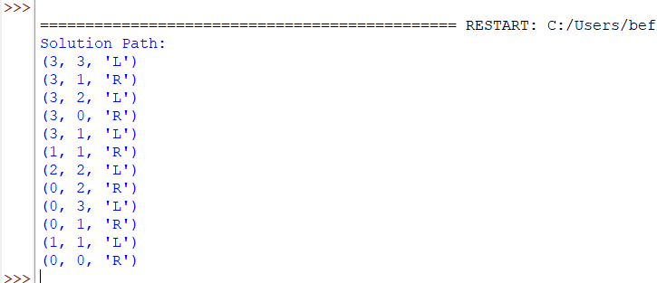

RESULT:
Thus, the Python program to solve the Missionaries and Cannibals Problem using the Breadth-First Search (BFS) algorithm was successfully implemented and executed.

6.Write a Python Problem to Solve Vacuum Cleaner Problem?

AIM:
To write a Python program to simulate the Vacuum Cleaner Problem using a simple reflex agent.
ALGORITHM:
- Initialize two rooms (A and B) with their status (Clean/Dirty).
- Place the vacuum cleaner in one of the rooms.
- Check the current room:
- If the room is dirty, clean it.
- Otherwise, move to the next room.
- Repeat the process until both rooms are clean.
- Display the actions performed by the vacuum cleaner.
CODE:
# Vacuum Cleaner Problem
rooms = {'A': 'Dirty', 'B': 'Dirty'}
location = 'A'
while True:
if rooms[location] == 'Dirty':
print(location, ": Dirty -> Cleaning")
rooms[location] = 'Clean'
else:
print(location, ": Clean")
if location == 'A':
location = 'B'
else:
break
print("\nFinal Room Status:")
for room in rooms:
print(room, ":", rooms[room])
print("\nAll rooms are clean.")

OUTPUT:

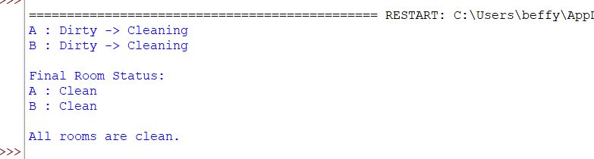

RESULT:
Thus, the Python program to solve the Vacuum Cleaner Problem was successfully implemented and executed, and both rooms were cleaned successfully.

7.Write a Python Program to Implement BFS?

AIM:
To write a Python program to implement the Breadth-First Search (BFS) algorithm for graph traversal.
ALGORITHM:
- Create a graph using an adjacency list.
- Select the starting node.
- Mark the starting node as visited and add it to a queue.
- Remove a node from the queue and display it.
- Visit all its unvisited adjacent nodes and add them to the queue.
- Repeat Steps 4 and 5 until the queue becomes empty.
- Display the BFS traversal.
CODE:
from collections import deque
graph = {
'A': ['B', 'C'],
'B': ['D', 'E'],
'C': ['F'],
'D': [],
'E': ['F'],
'F': []
}
visited = set()
queue = deque()

start = 'A'
visited.add(start)
queue.append(start)
print("BFS Traversal:")
while queue:
node = queue.popleft()
print(node, end=" ")
for neighbour in graph[node]:
if neighbour not in visited:
visited.add(neighbour)
queue.append(neighbour)

OUTPUT:

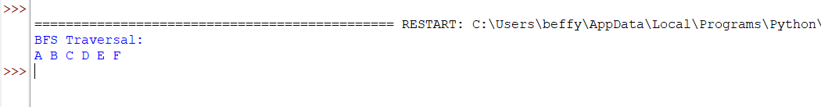

RESULT:
Thus, the Python program to implement the Breadth-First Search (BFS) algorithm was successfully executed, and the graph was traversed in breadth-first order.

8.Write a Python Program to Implement DFS?

AIM:
To write a Python program to implement the Depth-First Search (DFS) algorithm for graph traversal.

ALGORITHM:
- Create a graph using an adjacency list.
- Select the starting node.
- Mark the starting node as visited.
- Display the current node.
- Recursively visit all unvisited adjacent nodes.
- Repeat the process until all reachable nodes are visited.
- Display the DFS traversal.

CODE:
graph = {
'A': ['B', 'C'],
'B': ['D', 'E'],
'C': ['F'],
'D': [],
'E': ['F'],
'F': []
}
visited = set()
def dfs(node):
if node not in visited:
print(node, end=" ")
visited.add(node)
for neighbour in graph[node]:
dfs(neighbour)
print("DFS Traversal:")
dfs('A')

OUTPUT:

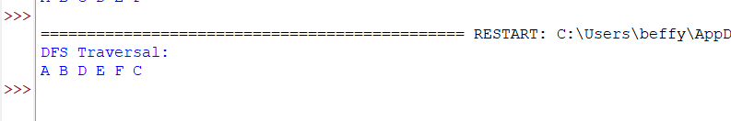

RESULT:
Thus, the Python program to implement the Depth-First Search (DFS) algorithm was successfully executed, and the graph was traversed in depth-first order.

9.Write a Python to Implement Travelling Salesman Problem?

AIM:
To write a Python program to solve the Travelling Salesman Problem (TSP) by finding the minimum-cost route that visits each city exactly once and returns to the starting city.

ALGORITHM:
- Define the distance matrix between all cities.
- Select the starting city.
- Generate all possible routes using permutations.
- Calculate the total distance for each route.
- Compare the distances of all routes.
- Select the route with the minimum total distance.
- Display the optimal route and its minimum cost.

CODE:
from itertools import permutations
graph = [
[0, 10, 15, 20],
[10, 0, 35, 25],
[15, 35, 0, 30],
[20, 25, 30, 0]
]
n = len(graph)
cities = range(1, n)
min_cost = float('inf')
best_path = ()
for path in permutations(cities):
cost = 0
current = 0
for city in path:
cost += graph[current][city]
current = city
cost += graph[current][0]
if cost < min_cost:
min_cost = cost
best_path = (0,) + path + (0,)
print("Minimum Cost:", min_cost)
print("Optimal Path:", best_path)

OUTPUT:
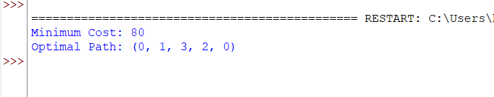

RESULT:
Thus, the Python program to solve the Travelling Salesman Problem (TSP) was successfully implemented and executed, and the optimal path with the minimum travel cost was obtained.
10.Write a Python Program to Implement A*Algorithm?

AIM:
To write a Python program to implement the A* (A-Star) Search Algorithm to find the shortest path between a start node and a goal node.
AIGORITHM:
- Define the graph with nodes and edge costs.
- Assign heuristic values to each node.
- Initialize the open list with the start node.
- Select the node with the lowest f(n) = g(n) + h(n) value.
- Expand the selected node and calculate the cost of its neighboring nodes.
- Update the open list with unvisited neighbors.
- Repeat the process until the goal node is reached.
- Display the shortest path and its total cost.
CODE:
graph = {
'A': [('B', 1), ('C', 3)],
'B': [('D', 3), ('E', 6)],
'C': [('F', 5)],
'D': [('G', 2)],
'E': [('G', 1)],
'F': [('G', 2)],
'G': []
}

heuristic = {
'A': 7,
'B': 6,
'C': 4,
'D': 2,
'E': 1,
'F': 2,
'G': 0
}
open_list = [('A', 0)]
closed_list = set()
parent = {'A': None}
cost = {'A': 0}
while open_list:
open_list.sort(key=lambda x: cost[x[0]] + heuristic[x[0]])
current = open_list.pop(0)[0]
if current == 'G':
break
closed_list.add(current)
for neighbor, weight in graph[current]:
new_cost = cost[current] + weight
if neighbor not in cost or new_cost < cost[neighbor]:
cost[neighbor] = new_cost
parent[neighbor] = current
if neighbor not in closed_list:
open_list.append((neighbor, new_cost))
path = []
node = 'G'
while node is not None:
path.append(node)
node = parent[node]
path.reverse()
print("Shortest Path:", " -> ".join(path))
print("Total Cost:", cost['G'])

OUTPUT:

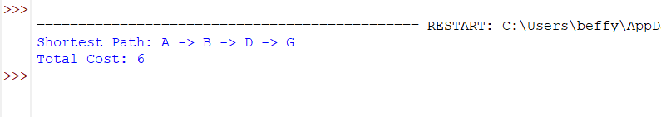

RESULT:
Thus, the Python program to implement the A* (A-Star) Search Algorithm was successfully executed, and the shortest path from the start node to the goal node was obtained.
11.Write a Python Program for Map Coloring to Implement CSP?

AIM:
To write a Python program to solve the Map Coloring Problem using the Constraint Satisfaction Problem (CSP) approach.
ALGORITHM:
- Define the map with its neighboring regions.
- Define the available colors.
- Assign colors to each region one by one.
- Check whether the assigned color is different from the colors of neighboring regions.
- If a conflict occurs, try another color (backtracking).
- Repeat until all regions are assigned valid colors.
- Display the color assigned to each region.
CODE:
# Map Coloring using CSP (Backtracking)
regions = ['A', 'B', 'C', 'D']
neighbors = {
'A': ['B', 'C'],
'B': ['A', 'C', 'D'],
'C': ['A', 'B', 'D'],
'D': ['B', 'C']
}
colors = ['Red', 'Green', 'Blue']
assignment = {}
def is_safe(region, color):
for neighbor in neighbors[region]:
if neighbor in assignment and assignment[neighbor] == color:
return False
return True
def solve(index):
if index == len(regions):
return True
region = regions[index]
for color in colors:
if is_safe(region, color):
assignment[region] = color
if solve(index + 1):
return True
del assignment[region]
return False
if solve(0):
print("Map Coloring Solution:")
for region in regions:
print(region, ":", assignment[region])
else:
print("No solution exists.")

OUTPUT:

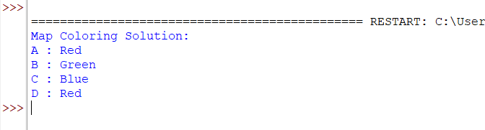

RESULT:
Thus, the Python program to solve the Map Coloring Problem using the Constraint Satisfaction Problem (CSP) was successfully implemented and executed, and valid colors were assigned to all regions without violating the constraints.
12.Writw a Python Program for Tic Tac Toe Game?

AIM:
To write a Python program to implement a Tic-Tac-Toe Game for two players.

ALGORITHM:
- Create a 3×3 game board.
- Display the board.
- Allow Player X and Player O to enter their moves.
- Update the board after each valid move.
- Check for a winning row, column, or diagonal.
- If a player wins, display the winner and stop the game.

CODE:
# Tic-Tac-Toe Game
board = [' '] * 9
def display():
print()
print(board[0], '|', board[1], '|', board[2])
print('--+---+--')
print(board[3], '|', board[4], '|', board[5])
print('--+---+--')
print(board[6], '|', board[7], '|', board[8])
print()
def check_winner(player):
win = [
[0,1,2], [3,4,5], [6,7,8],
[0,3,6], [1,4,7], [2,5,8],
[0,4,8], [2,4,6]
]
for x in win:
if all(board[i] == player for i in x):
return True
return False
player = 'X'
for turn in range(9):
display()
pos = int(input(f"Player {player}, Enter position (1-9): ")) - 1
if board[pos] == ' ':
board[pos] = player
if check_winner(player):
display()
print("Player", player, "Wins!")
break
player = 'O' if player == 'X' else 'X'
else:
print("Position already occupied!")
else:
display()
print("Match Draw!")
OUTPUT:

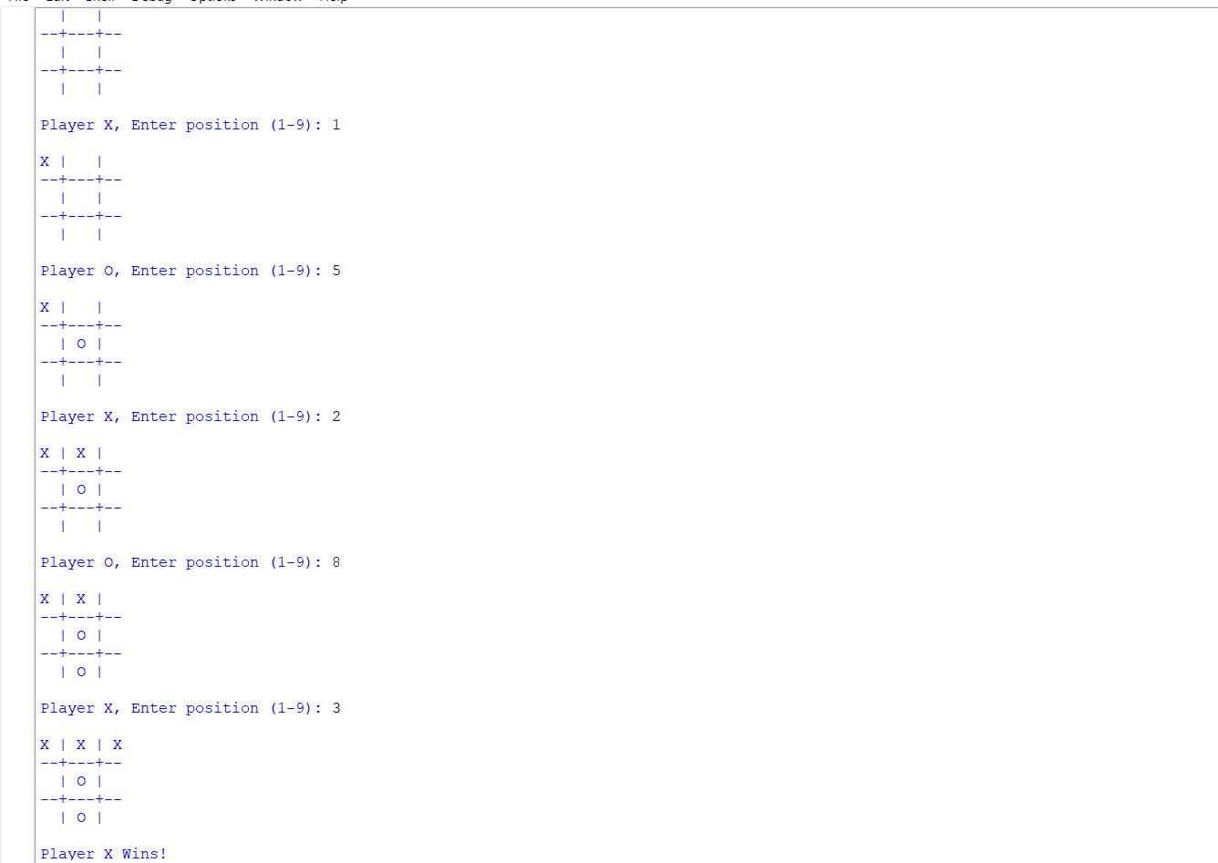

RESULT:
Thus, the Python program to implement the Tic-Tac-Toe Game was successfully executed, allowing two players to play the game and correctly determining the winner or a draw.

13.Write a Python Program to Implement Minimax Algorithm for Gaming?

AIM:
To write a Python program to implement the Minimax Algorithm for game playing and determine the optimal move.

ALGORITHM:
- Define the game tree with terminal node values.
- Specify the depth of the tree and whether the current player is the maximizer or minimizer.
- If a terminal node is reached, return its value.
- If it is the maximizer's turn, choose the maximum value from its child nodes.
- If it is the minimizer's turn, choose the minimum value from its child nodes.
- Continue recursively until the root node is evaluated.
- Display the optimal value obtained using the Minimax algorithm.

CODE:
import math
# Terminal node values
scores = [3, 5, 2, 9, 12, 5, 23, 23]
def minimax(depth, nodeIndex, isMax):
if depth == 3:
return scores[nodeIndex]
if isMax:
return max(
minimax(depth + 1, nodeIndex * 2, False),
minimax(depth + 1, nodeIndex * 2 + 1, False)
)

else:
return min(
minimax(depth + 1, nodeIndex * 2, True),
minimax(depth + 1, nodeIndex * 2 + 1, True)
)
result = minimax(0, 0, True)
print("Optimal Value:", result)

OUTPUT:

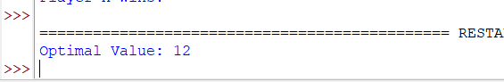

RESULT:
Thus, the Python program to implement the Minimax Algorithm for game playing was successfully executed, and the optimal value was obtained.

14.Write a Python Program to Implement Alpha Beta Pruning Algorithm for Gaming?

AIM:
To write a Python program to implement the Alpha-Beta Pruning Algorithm for game playing and determine the optimal move by pruning unnecessary branches.

ALGORITHM:
- Define the terminal node values of the game tree.
- Initialize alpha = -∞ and beta = +∞.
- Start from the root node.
- If it is the maximizer's turn, update the alpha value with the maximum score.
- If it is the minimizer's turn, update the beta value with the minimum score.
- If alpha ≥ beta, prune the remaining branches.
- Continue until the entire tree is evaluated.
- Display the optimal value.

CODE:
import math
# Terminal node values
scores = [3, 5, 6, 9, 1, 2, 0, -1]
def alphabeta(depth, nodeIndex, isMax, alpha, beta):
if depth == 3:
return scores[nodeIndex]
if isMax:
best = -math.inf
for i in range(2):
value = alphabeta(depth + 1, nodeIndex * 2 + i, False, alpha, beta)
best = max(best, value)
alpha = max(alpha, best)
if beta <= alpha:
break
return best
else:
best = math.inf
for i in range(2):
value = alphabeta(depth + 1, nodeIndex * 2 + i, True, alpha, beta)
best = min(best, value)
beta = min(beta, best)
if beta <= alpha:
break
return best
result = alphabeta(0, 0, True, -math.inf, math.inf)
print("Optimal Value:", result)

OUTPUT:

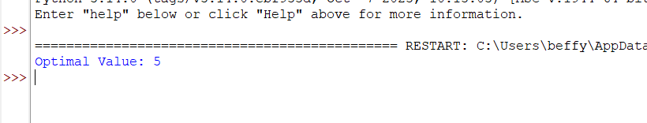

RESULT:
Thus, the Python program to implement the Alpha-Beta Pruning Algorithm for game playing was successfully executed, and the optimal value was obtained after pruning unnecessary branches.

15.Write a Python Program to Implement Decision Tree?

AIM:
To write a Python program to implement the Decision Tree algorithm for classification.
ALGORITHM:
- Import the required libraries.
- Load a sample dataset.
- Split the dataset into training and testing sets.
- Create a Decision Tree classifier.
- Train the model using the training data.
- Predict the class labels for the test data.
- Display the predicted values and accuracy of the model.
CODE:
# Decision Tree using ID3 Algorithm (Without sklearn)
dataset = [
["Sunny", "Hot", "No"],
["Sunny", "Cool", "Yes"],
["Rainy", "Cool", "Yes"],
["Rainy", "Hot", "No"]
]
def entropy(data):
yes = sum(1 for row in data if row[-1] == "Yes")
no = len(data) - yes
if yes == 0 or no == 0:
return 0
from math import log2
p1 = yes / len(data)
p2 = no / len(data)
return -(p1 * log2(p1) + p2 * log2(p2))
def information_gain(data, col):
total_entropy = entropy(data)
values = {}
for row in data:
values.setdefault(row[col], []).append(row)
weighted_entropy = 0
for subset in values.values():
weighted_entropy += (len(subset) / len(data)) * entropy(subset)
return total_entropy - weighted_entropy
gain0 = information_gain(dataset, 0)
gain1 = information_gain(dataset, 1)
print("Information Gain (Outlook):", round(gain0, 3))
print("Information Gain (Temperature):", round(gain1, 3))
if gain0 > gain1:
print("Root Node: Outlook")
else:
print("Root Node: Temperature")

OUTPUT:

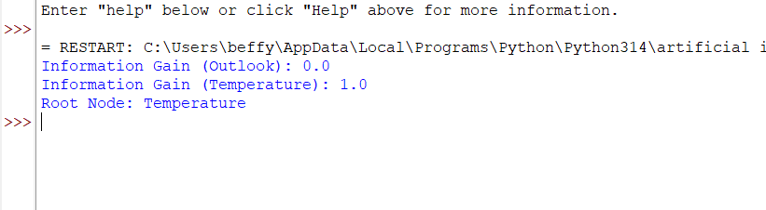

RESULT:
Thus, the Python program to implement the Decision Tree algorithm was successfully executed, and the class label for the given input was predicted.

16. Write a Python Program to Implement Feed Forward Neural Network?

AIM:
To write a Python program to implement a Feed Forward Neural Network (FFNN).
ALGORITHM:
- Initialize the input values, weights, and bias.
- Calculate the weighted sum of the inputs.
- Apply the sigmoid activation function.
- Compute the output of the hidden layer.
- Calculate the output neuron value.
- Display the final output of the network.
CODE:
import math
# Sigmoid Activation Function
def sigmoid(x):
return 1 / (1 + math.exp(-x))
# Input values
x1 = 0.5
x2 = 0.8
# Weights from Input Layer to Hidden Layer
w1 = 0.2
w2 = 0.4
w3 = 0.3
w4 = 0.1
# Weights from Hidden Layer to Output Layer
w5 = 0.6
w6 = 0.5
# Bias
b1 = 0.5
b2 = 0.7
# Hidden Layer
h1 = sigmoid(x1 * w1 + x2 * w2 + b1)
h2 = sigmoid(x1 * w3 + x2 * w4 + b1)
# Output Layer
output = sigmoid(h1 * w5 + h2 * w6 + b2)
print("Hidden Neuron 1 =", round(h1, 4))
print("Hidden Neuron 2 =", round(h2, 4))
print("Output =", round(output, 4))

OUTPUT:

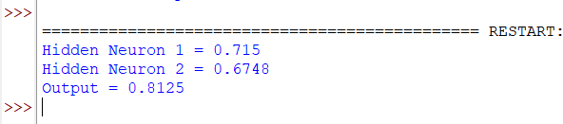

RESULT:
Thus,the Python program to implement a Feed Forward Neural Network(FFNN)was successsfully executed, and the output of the network was obtained using the sigmoid activation function

17.Write a prolog program to sum the integer from 1 to n?

AIM:
To write a Prolog program to find the sum of integers from 1 to N.
ALGORITHM:
- Define the base case: the sum of 1 is 1.
- Define the recursive case:
  - Compute the sum of integers from 1 to N-1.
  - Add N to the result.
- Execute the query by passing the value of N.
- Display the sum.
CODE:
sum(1, 1).
sum(N, S) :-
N > 1,
N1 is N - 1,
sum(N1, S1),
S is S1 + N.

OUTPUT
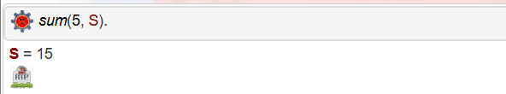

RESULT:
Thus, the Prolog program to find the sum of integers from 1 to N was successfully executed, and the required sum was obtained.

